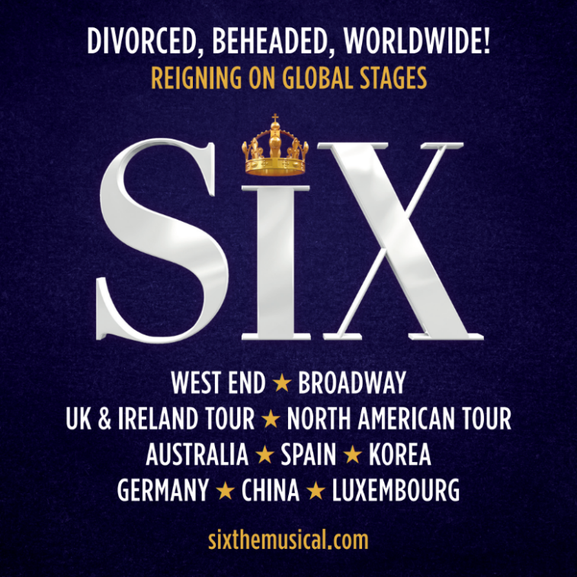
SIX THE MUSICAL
EXTENDS WEST END RUN AT THE VAUDEVILLE THEATRE UNTIL NOVEMBER 2027

AS THE QUEENDOM CONTINUES TO REIGN SUPREME ON GLOBAL STAGES
IN LONDON, ON TOUR, AND AROUND THE WORLD

ALSO IN 2026: SIX OPENS IN SPAIN, RETURNS TO AUSTRALIA AND CHINA, AND HEADS TO NORTH AMERICAN CINEMAS
FURTHER INTERNATIONAL DATES INCLUDE GERMANY IN 2026 AND LUXEMBOURG IN 2027

DIVORCED, BEHEADED, WORLDWIDE!

[Saturday 6 June, London] The producers of SIX are delighted to announce that the West End production has extended its reign at the Vaudeville Theatre, with tickets now on sale for performances until Sunday 28 November 2027, with tickets available now via www.sixthemusical.com.

The announcement follows a remarkable period of continued international success for the home-grown British musical, which began life as a student production at the Edinburgh Fringe in 2017 and has since become a global phenomenon.

SIX follows the six wives of Henry VIII as they take to the mic to tell their own personal tales, remixing five hundred years of historical heartbreak into an 80-minute celebration of 21st century girl power.

The musical’s global reach grows further in 2026, with a new Spanish language production opening at Teatro Gran Vía in Madrid this September. Ahead of its premiere, the Spanish cast released Ex-Wives / SIX, the first official Spanish language recording from the musical, available to stream across all digital platforms alongside an official music video.

SIX continues its reign on Broadway at the Lena Horne Theatre and is now booking into its fifth year. The musical has toured the USA, Australia, New Zealand, Japan, Singapore, the Philippines, South Korea, the Netherlands, Germany, Italy and Switzerland, and enjoyed a seven-week season at the Venetian Resort in Las Vegas.

This year, SIX returns to Australia with a national tour kicking off in Melbourne before heading to Sydney and Brisbane; China for a 12-week engagement from October, alongside further international dates in Germany, visiting Munich, Frankfurt, Düsseldorf and Berlin, and performances at the Grand Théâtre de Luxembourg in May 2027.

Back on home turf, the London production continues to hold court in the West End and continues its reign at the Vaudeville Theatre, whilst nationally, the UK tour, now booking through to November 2027, continues to break Box Office records.

Winner of over 35 major international awards including the 2022 Tony Award for Best Original Score and Best Costume Design on Broadway, triple Whatsonstage Award winner for Best West End Show 2022, 2023 and 2025, and the 2020 BBC Radio 2 Audience Award for Best Musical, SIX was also nominated for five Olivier awards, including Best New Musical. The original studio album of SIX was officially certified Platinum in 2026, with the Broadway album SIX: Live on Opening Night nominated for a Grammy Award and, collectively, the music has been listened to over 5.5 billion times.

In 2025, the live captured event cinema release of SIX the Musical! Live was seen in cinemas across the UK on 750 screens, broadcast on the most screens of any limited release cinema event, beating Taylor Swift’s Eras tour. In 2026, SIX the Musical Live! will be released in cinemas across the US and Canada on over 1,000 screens.

Think you know the six Wives of Henry VIII? Think again…

Prepare to lose your head and experience the Tudor Wives’ lives as they turn back the clock and take to the stage to reclaim their crowns and retell their stories of love, loss and the infamous ex they all have in common.

Join Aragon, Boleyn, Seymour, Cleves, Howard and Parr, backed by their fierce on-stage band, the Ladies in Waiting, and Get Down to a royal retelling of the sassiest story in British Her-story.

SIX is written by Toby Marlow and Lucy Moss, with direction by Lucy Moss and Jamie Armitage. Choreography is by Carrie-Anne Ingrouille, with set design by Emma Bailey, costume design by Gabriella Slade, lighting design by Tim Deiling, sound design by Paul Gatehouse, musical orchestration by Tom Curran, and musical supervision by Joe Beighton, and casting by Pearson Casting.

SIX is produced by Kenny Wax, Wendy & Andy Barnes and George Stiles.
The current West End Queens are Adrianne Langley (Titanique – Criterion Theatre; Twist and Shout – UK Tour) as ‘Catherine of Aragon’, Marisha Morgan (Tina – West End; Charlie and the Chocolate Factory – UK Tour; Anyone Can Whistle – Southwark Playhouse) as ‘Anne Boleyn’. Jessica Aubrey (Wicked – West End; Titanique – Lido Paris; But I’m A Cheerleader – Turbine Theatre) as ‘Jane Seymour’, with Freya Karlettis (Play On! – UK Tour; Hairspray; The Lion King) as ‘Anna of Cleves’, Leesa Tulley (Why Am I So Single – Garrick Theatre; SIX – UK Tour) as ‘Katherine Howard’, and Nia Stephen (&Juliet – UK Tour; The Enormous Crocodile – Regent’s Park) who makes her West End debut as ‘Catherine Parr’.
They are joined by Tegan Bannister (Oliver! – Gielgud Theatre & Chichester; I Should Be So Lucky – UK Tour; Les Misérables – West End & UK Tour) as Alternate ‘Aragon/Cleves’, Mary Elliott as Alternate ‘Boleyn/Howard’, and Ashlyn Weekes (Dear Evan Hansen – Asia Tour; Starlight Express – Wembley Park; The Royal Variety Performance 2024) as Alternate ‘Seymour/Parr’. The company is completed by Super Swings Laura Baxter, who is continuing from the 2025 cast in which she made her professional and West End debut, Gabs Boumford (SIX – Australasian Tour; Grease – Dubai Opera) and Imogen Rose Hart (Hamilton – UK Tour; A Chorus Line – Leicester Curve & Sadler’s Wells; Your Lie in April – Theatre Royal Drury Lane).
The band features Ladies in Waiting Beth Jerem as Musical Director/Keys, Alice Angliss on Drums, Emma Jemima on Guitar, Kelly Morris on Bass, and Annabelle Lee Revak as Assistant Musical Director.
Tickets to all international productions of SIX are available via sixthemusical.com

[ENDS]

LISTINGS INFO UK
SIX
Vaudeville Theatre
404 Strand,
London, WC2R 0NH

Booking period
To 28 November 2027
Tuesday, Wednesday & Friday 8pm
Thursday 4pm & 8pm
Saturday 4pm & 8pm
Sunday 3pm & 7pm
Duration: 80 minutes no interval
Age recommendation: 10+
Tickets: from £34.50
No booking fee if booked in person at the box office
Box office: 0330 333 4814
www.nimaxtheatres.com
All tickets include a £1.50 Theatre Restoration Levy

Sing-Along Performances
TBC

Access Performances
Audio Described:
Sunday 26 July 2026 at 3pm
Saturday 24 October 2026 at 8pm

Captioned:
Saturday 18 July 2026 at 8pm
Saturday 17 October 2-26 at 4pm

British Sign Language:
Sunday 12 July 2026 at 3pm
Saturday 10 October 2026 at 8pm

Social media:
Facebook: sixthemusical
Twitter: @sixthemusical
Instagram: @sixthemusical
www.sixthemusical.com

