HARRY POTTER AND THE CURSED CHILD
FIRST CAST ANNOUNCED FOR REIMAGINED ONE-PART PRODUCTION

HISTORIC, RECORD-BREAKING ORIGINAL TWO-PART PRODUCTION ENTERS FINAL WEEK AFTER GROUND-BREAKING TEN-YEAR RUN
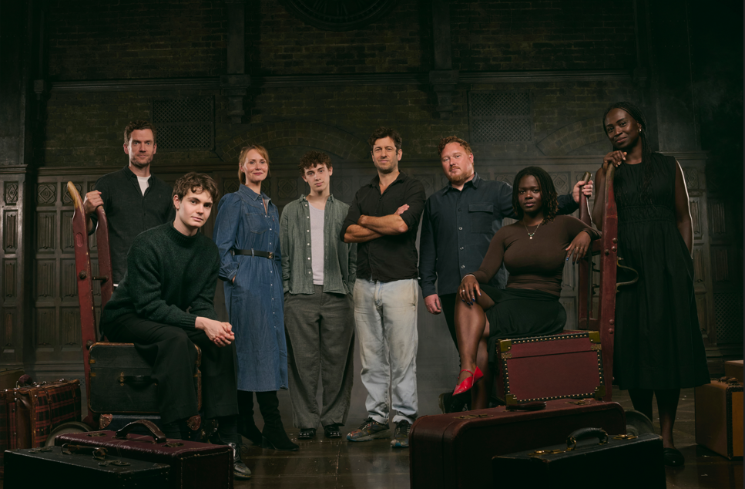
New cast set-up images can be downloaded here (Photographer credit: Matt Crockett)
Today, 15 September 2026, the producers of Harry Potter and the Cursed Child - Sonia Friedman Productions, Colin Callender and Harry Potter Theatrical Productions - are delighted to introduce the first cast who will take to the stage in the reimagined one-part production, which begins performances on 9 October at the Palace Theatre.

The announcement comes as the sold-out original two-part production enters its final week at the Palace Theatre, concluding a historic, record-breaking and ground-breaking ten-year run. The multi award-winning production will play its final performance on 20 September 2026, as previously announced, before the reimagined one-part version begins performances in October.

The new cast comprises Ethan Rouse as Albus Potter, Zoë Rainey as Ginny Potter, with Hasia Akwaboah playing Rose Granger-Weasley. Adam Jackson-Smith will play Draco Malfoy and Bill Stanley also joins the cast to play his son Scorpius Malfoy. They will perform alongside continuing cast members David Ricardo-Pearce as Harry Potter, Thomas Aldridge as Ron Weasley and Naana Agyei Ampadu as Hermione Granger.

They are joined by Dewayne Jameson Adams, David Annen, Jacqueline Beaumont, Jensen Bedford, Angeline Bell, Tatum Confrey, Robert Curtis, Nick Dennington, Shakhai Estwick, Miah Hasselbaink, Tim Hibberd, Becky Hoyle, Max Hutchinson, Danny Ivy, Emma Louise Jones, Laura June Ness, Louise Ludgate, Shreya Lallu, Nathan Muwowo, Jocelyn Prah, Claire Redcliffe, Ewan Rutherford, Joshua Talbot, Nathaniel Tan, Callum Tempest, Alex Tomkins, Jake Tuesley and Aidan Garrett Wilkins.

19 years after Harry, Ron, and Hermione saved the wizarding world, they’re back on a most extraordinary new adventure – this time, joined by a brave new generation that has only just arrived at the legendary Hogwarts School of Witchcraft and Wizardry. Prepare for spectacular spells, a mind-blowing race through time, and an epic battle to stop mysterious forces, all while the future hangs in the balance.

Over the last decade Harry Potter and the Cursed Child has become a global success having been by seen more than 14 million people worldwide, including over 2.5million at its London home. The production received a record-breaking 9 Laurence Olivier Awards - the highest number awarded for a play, as well as multiple other UK theatre awards, and has now received a record 60 major honours globally, including 6 Tony Awards. There are 5 productions of Harry Potter and the Cursed Child currently running - London, New York, Tokyo, the Netherlands and a North American tour, with previous productions staged in Hamburg, Melbourne, San Francisco and Toronto.

Based on an original new story by J.K. Rowling, Jack Thorne and John Tiffany, Harry Potter and the Cursed Child is a new play by Jack Thorne, directed by John Tiffany with movement by Steven Hoggett, set by Christine Jones, costumes by Katrina Lindsay, music & arrangements by Imogen Heap, lighting by Neil Austin, sound by Gareth Fry, illusions & magic by Jamie Harrison, music supervision & arrangements by Martin Lowe, and casting by Julia Horan CDG and Lotte Hines CDG. Harry Potter and the Cursed Child is produced by Sonia Friedman Productions, Colin Callender and Harry Potter Theatrical Productions.

Currently booking to 27 June 2027, tickets for the reimagined one-part production, which is told in one complete performance, are priced from £25. The performance schedule for the one-part production is Tuesday to Saturday at 7pm, Wednesday and Saturday at 1pm, and Sunday at 2:30pm.

The access performances currently on sale are as follows – British Sign Language Performances on Sunday 17 January 2027 at 2:30pm and Sunday 9 May 2027 at 2:30pm, and Captioned Performances on Sunday 31 January 2027 at 2.30pm and Sunday 16 May 2027 at 2.30pm.

For current cast production images, EPK, and artwork please click here

***ENDS***

Harry Potter and the Cursed Child – Palace Theatre:

Box Office – 0330 333 4813
WWW.HARRYPOTTERTHEPLAY.COM
Instagram / CursedChildLDN
TikTok / CursedChildOfficial
Facebook / CursedChildLDN
WizardingWorld.com

One-Part Performance Schedule from 9 October:

Tuesday 7pm
Wednesday 1pm and 7pm
Thursday 7pm
Friday 7pm
Saturday 1pm and 7pm
Sunday 2.30pm

Access performances:

British Sign Language Performances:
Sunday 17 January 2027 at 2:30pm
Sunday 9 May 2027 at 2:30pm

Captioned Performances:
Sunday 31 January 2027 at 2.30pm
Sunday 16 May 2027 at 2.30pm

Christmas 2026 performance schedule

Tuesday 22 December 2026 at 1pm and 7pm
Wednesday 23 December 2026 at 1pm and 7pm
Thursday 24 December 2026 at 1pm
Sunday 27 December 2026 at 1pm and 7pm
Tuesday 29 December 2026 at 1pm and 7pm
Wednesday 30 December 2026 at 1pm and 7pm
Thursday 31 December 2026 at 1pm
Friday 1 January 2027 at 5pm
Saturday 2 January 2027 at 1pm and 7pm
Sunday 3 January 2027 at 2.30pm

